# Brainstorm

### Before you collaborate

A little bit of preparation goes a long way with this session. Here’s what you need to do to get going.

**10 minutes**

**1**

**Define your problem statement**

farmers should be in the farm field to monitor their crop field,if any emergency occurs for

farmer to go outside there will be lack of irrigation in farm field which lead to damage of crops

This is a text box...

### 2

**Brainstorm**

Write down any ideas that come to mind that address your problem statement.

**10 minutes**

### 3

**Group ideas**

Take turns sharing your ideas while clustering similar or related notes as you go. In the last 10 minutes, give each cluster a sentence-like label. If a cluster is bigger than six sticky notes, try and see if you and break it up into smaller sub-groups.

**20 minutes**

### 4

**Prioritize**

Your team should all be on the same page about what's important moving forward. Place your ideas on this grid to determine which ideas are important and which are feasible.

**20 minutes**

### After you collaborate

You can export the mural as an image or pdf to share with members of your company who might find it helpful.

**Quick add-ons**

**PROBLEM**

**Not able to control and monitor crops remotely**

# & idea prioritization

**A Team gathering**

ashwin kumar ,tamilvanan,someshwaran,suriya

**Soundharrajan**

**TIP**

Add customizable tags to sticky notes to make it easier to find, browse, organize, and categorize important ideas as themes within your mural.

automated

**Rubesh**

controlling

**Sundar**

**Nandhakumar**

1. **Share the mural**

Use this template in your own brainstorming sessions so your team can unleash their imagination and start shaping concepts even if you're not sitting in the same room.

1. **Set the goal**

controlling and monitoring crops remotely

1. This is a title...

This is a text box...

monitoring crops using sensors

controling irrigation remotely using internet

farming if farmer is not present

irrigation through smartphone

flexible ui interface

internet of things

irrigation calandar

sensor parameter database

crop health prediction

temperature sensor

humidity sensor

soil moisture sensor

Farmer:

controlling and monitoring crops remotely using smartphone

autonomous irrigation mode

**Share a view link** to the mural with stakeholders to keep them in the loop about the outcomes of the session.

**B Export the mural**

Export a copy of the mural as a PNG or PDF to attach to emails, include in slides, or save in your drive.

**10 minutes** to prepare

**1 hour** to collaborate

**2-8 people** recommended

[**Open article**](https://support.mural.co/en/articles/2113740-facilitation-superpowers)

### Key rules of brainstorming

providing solution on time

To run an smooth and productive session

specification:

## 

monitoring temperature

,humidity and soil moisture using sensors

controlling irrigation and if needed autonomously

architecture:

**Keep moving forward**

**Strategy blueprint**

Define the components of a new idea or strategy.

[**Open the template**](https://app.mural.co/template/e95f612a-f72a-4772-bc48-545aaa04e0c9/984865a6-0a96-4472-a48d-47639307b3ca)

**Customer experience journey map**

Stay in topic. Defer judgment.

Encourage wild ideas. Listen to others.

dc moror

microcomputer

Temperature sesnor

### Importance

If each of these

mobile

database

Understand customer needs, motivations, and obstacles for an experience.

[**Open the template**](https://app.mural.co/template/b7114010-3a67-4d63-a51d-6f2cedc9633f/c1b465ab-57af-4624-8faf-ebb312edc0eb)

deal with problem quickly

Go for volume. If possible, be visual.

humidity sensor

wifi module

tasks could get

done without any difficulty or cost, which would have the most positive impact?

**Strengths, weaknesses, opportunities & threats**

Identify strengths, weaknesses, opportunities, and threats (SWOT) to develop a plan.

|  |  |
| --- | --- |
|  |  |
|  |  |

[**Open the template**](https://app.mural.co/template/6a062671-89ee-4b76-9409-2603d8b098be/ca270343-1d54-4952-9d8c-fbc303ffd0f2)

moisture sensor

**TIP**

Participants can use their cursors to point at where sticky notes should go on the grid. The facilitator can confirm the spot by using the laser pointer holding the **H key** on the keyboard.

[**Share template feedback**](https://muralco.typeform.com/to/CiqaHVat?typeform-source=app.mural.co)

[**Share template feedback**](https://muralco.typeform.com/to/CiqaHVat?typeform-source=app.mural.co)

### Feasibility

Regardless of their importance, which tasks are more feasible than others? (Cost, time, effort, complexity, etc.)

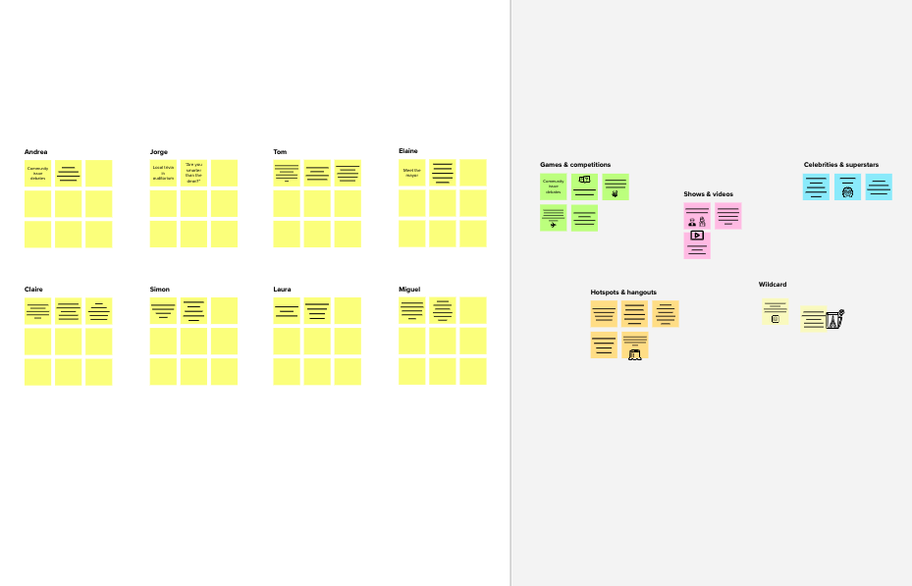

**Template**

**Need some inspiration?**

See a finished version of this template to kickstart your work.

[**Open example**](https://app.mural.co/template/e5a93b7b-49f2-48c9-afd7-a635d860eba6/93f1b98d-b2d2-4695-8e85-7e9c0d2fd9b9)